Case 6-Asia-China-Sichuan-Sanxingdui-三星堆-3700-2100 BCE

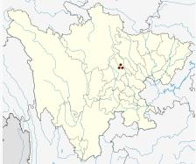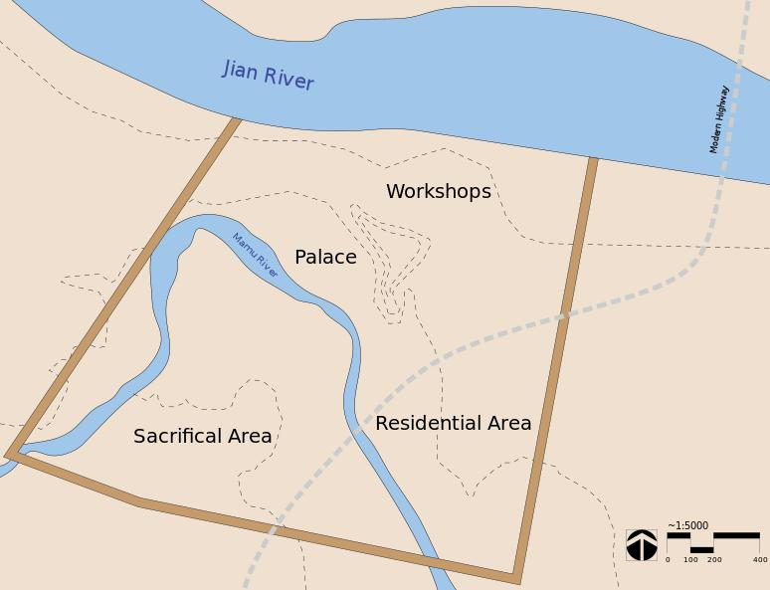

Sanxingdui site (30° 59′ 34.8″ N, 104° 12′ 0″ E). Left, Location in Sichuan Province; right map of city wall enclosing ca 2.6 sq. km. and 4 major cultural areas.

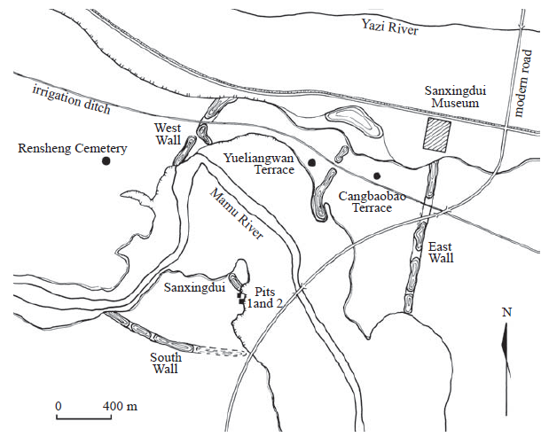

Figure 1. Map of the Sanxingdui site. After Bagley 2001: 24, fig. 1.

Sanxingdui-三星堆 (three star mound) is located about 10 km west of the city of Guanghan

廣漢, which is about 40 km northeast of Chengdu 成都, the capital of

Sichuan province (Sichuan 1999: 9, 15). Spread along the southern

bank of the Yazi River 鴨子河 and both sides of the Mamu River 馬

牧河, the site is presently known to cover an area of 10 to 17 sq. km as

determined by the distribution of artifacts.2 The center of the site is a walled enclosure that measures about 3.5 sq. km (350 ha) (Chen De’an

et al. 1998: 1) (Figure 1). The site is named after Sanxingdui because

of the major excavations in that area in 1980–1981, which established

the basic framework of periodization and cultural definition of the site,

and because of the discovery there in 1986 of K1 and K2, two “sacrificial

pits” filled with immense material wealth. These two pits revealed

the site to be a center of an early Bronze Age civilization previously

unknown.3

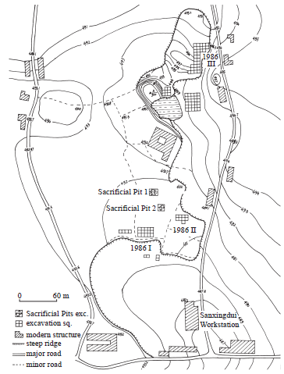

Figure 2. Excavation loci at Sanxingdui in 1986. Adapted from Sichuan 1999: 13, fig. 4.

The Sanxingdui culture was literally uncovered in 1929 when a farmer dug up a hoard of jade relics which made their way into the antiques market over the next five decades. However, not until 1980 was excavation begun on the site. It was discovered that its extensive walls were of a rammed earth, *hangtu* construction, which involved putting wet, lacustrine clay into wooden frames which was compacted to produce a uniformly hard layer 12-15 cm. thick. Several courses were laid to achieve the desired height (Knapp 2000; Rael 2009). An estimation as to the original height and geometry of the wall can then be made using a modeling technique that accounts for the degradation of the structure over time (Panin, Arzhantseva, Oleaga 2012). By this means the wall was estimated to enclose an area of 2.6 sq. km., indicating that it enclosed a major settlement.

In 1986 two sacrificial pits (K1 and K2) were discovered which were separated by a few decades, around 1200 BCE. In K1, the earlier pit, a unique ritual, an offering ceremony, was uncovered in which burned and broken artifacts of bronze, jade and gold, 13 elephant tusks, cowrie shells and burned animal bones were deposited into the pit. The jades included axes, tablets, rings, knives and tubular shapes with a central hole that were decorated with taotie-like images in relief. The second pit, K2, contained an even more rich content in three layers with more than a hundred jade artifacts, a bronze statue on a pedestal 262 cm tall, 41 bronze heads (some with gold leaf), bronze masks and three bronze trees (one 4 m tall). The art forms in these pits are of an entirely unknown Chinese culture which has been named Sanxingdui.

As far back as Neolithic times, the Chinese identified the four quadrants of the sky with animals: [Azure Dragon of the East](http://en.wikipedia.org/wiki/Azure_Dragon), [Vermillion Bird of the South](http://en.wikipedia.org/wiki/Vermilion_Bird), [White Tiger of the West](http://en.wikipedia.org/wiki/White_Tiger_%28Chinese_constellation%29), and [Black Tortoise of the North](http://en.wikipedia.org/wiki/Black_Tortoise). Each of these [Four Symbols (Chinese constellation)](http://en.wikipedia.org/wiki/Four_Symbols_%28Chinese_constellation%29) was associated with a constellation that was visible in the relevant season: the dragon in the spring, the bird in the summer, etc. Since these four animals — birds, dragons, snakes and tigers — predominate the finds at Sanxingdui,[[*citation needed*](http://en.wikipedia.org/wiki/Wikipedia:Citation_needed)] the bronzes could represent the universe.[[*citation needed*](http://en.wikipedia.org/wiki/Wikipedia:Citation_needed)] It is unclear whether they formed part of ritual events designed to communicate with the spirits of the universe (or ancestral spirits). As no written records remain it is difficult to determine the intended uses of objects found. Some believe that the continued presence of depictions of these animals, especially in the later Han period, was an attempt by humans to "fit into" their understanding of their world. (The jades that were found at Sanxingdui also seem to correlate with the six known types of ritual jades of ancient China, again each associated with a compass point (N, S, E, W) plus the heavens and earth.)

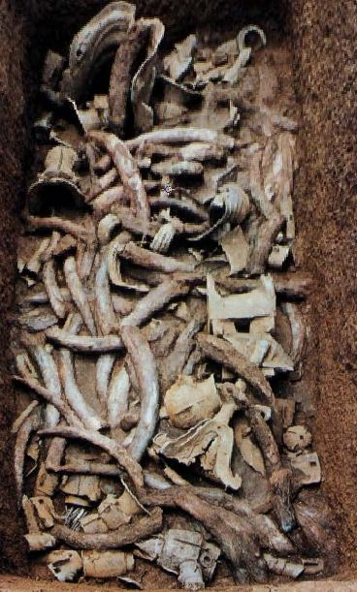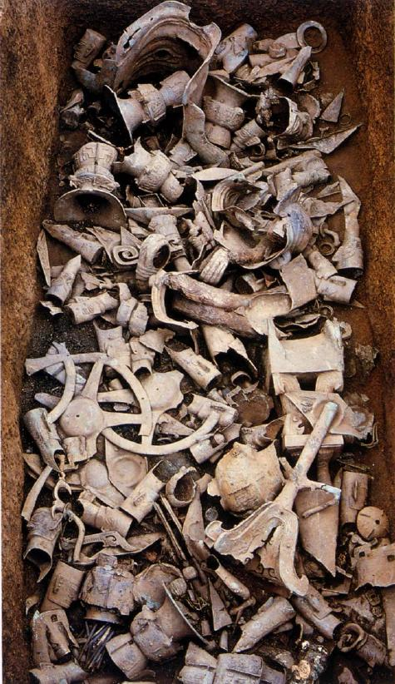

Fig. Left, Sanxingdui, K2 top layer after Taibei 1999: 194; right, K2 middle layer after Taibei 1999: 196.

Sanxingdui culture does not appear to have been in contact with the Bronze Age culture at Anyang. However after the abandonment of Sanxingdui in the 12th century BCE it appears that many relocated to a site about 50 km away.

This site named **Jinsha** ([金沙](http://en.wiktionary.org/wiki/%E9%87%91%E6%B2%99), *Jīnshā*) on the banks of the Modi River (摸底河) was discovered in February 2001 during building construction. Its excavation yielded artifacts of ivory, jade, bronze, gold and carved stone objects that suggests that it was the final phase of Sanxingdui culture that lasted until ca. 650 BCE as a political center in the Shu Kingdom. Unlike Sanxingdui there were no rammed earth fortification walls around the area of about five sq. km., roughly twice the size of its predecessor. Ivory, jade artifacts, bronze objects, gold objects and carved stone objects were found at the site. Unlike the site at Sanxingdui, Jinsha did not have a city wall. Jinsha culture (1200–650 BC) was a final phase of Sanxingdui culture and represents a relocation of the political center that some suggest was the ancient Shu Kingdom. (蜀; Shǔ) that was conquered by the state of [Qin](http://en.wikipedia.org/wiki/Qin_%28state%29) in 316 BCE (Yinke, Avery, Pan 2001: 171). Unfortunately, written accounts of Shu mostly date not earlier than the 4th century BCE and are largely a mixture of mythological stories and historical legends from local annals based on oral history. However there are possible references to "Shu" (蜀) in Shang oracle bone inscriptions, but it is not clear if they refer to the kingdom (Kleeman 1998: 19-22). The Shu was first mentioned in [*Shujing*](http://en.wikipedia.org/wiki/Shujing) (See Legge 1865, 1879) as one of the allies of [King Wu of Zhou](http://en.wikipedia.org/wiki/King_Wu_of_Zhou) who helped defeated the [Shang](http://en.wikipedia.org/wiki/Shang_Dynasty) in 1046 BC at the [Battle of Muye](http://en.wikipedia.org/wiki/Battle_of_Muye).[[2]](http://en.wikipedia.org/wiki/Shu_%28state%29#cite_note-2) However, shortly after Zhou's conquest, it was mentioned in [*Yizhoushu*](http://en.wikipedia.org/wiki/Yizhoushu) that a subordinate of King Wu led an expedition against Shu.[[1]](http://en.wikipedia.org/wiki/Shu_%28state%29#cite_note-ta_cheng-1) After the battle of Muye, northern influences on Shu seem to have increased and then decreased while the Shu remained culturally distinct; archaeology suggests contacts with Shu in the late Shang and early Zhou period, but little evidence of influence from later Zhou.[[1]](http://en.wikipedia.org/wiki/Shu_%28state%29#cite_note-ta_cheng-1) The expulsion of the Zhou from the [Wei River](http://en.wikipedia.org/wiki/Wei_River) valley in 771 BC probably increased Shu's isolation.

The unique bronze heads with bulging eyes that are found in both Sanxingdui and Jinsha may be elucidated by a bit of oral history preserved in the *Chronicles of Huayang* (華陽國志; Huáyáng Guó Zhì), which is devoted to the region south of Hua mountain, (**Hua Shan**: 華山; [*Huà*](http://en.wiktionary.org/wiki/Hu%C3%A0) [*Shān*](http://en.wiktionary.org/wiki/Sh%C4%81n)), one of China's Five Great Mountains. Hua Shan, located about 120 km. (75 mi.) east of [Xi'an](http://en.wikipedia.org/wiki/Xi%27an). **Hua Shan** has a long history of religious significance due in part to its majestic South Peak at 2,154.9 m. (7,070 ft.). In the *Chronicles,* compiledbetween 265 and 420 CE by Chang Qu during the Jin Dynasty, the first of the legendary kings named Cancong was reported to have had protruding eyes. Although the text is very late, its mention of the physical nature of this legendary king's eyes may have some bearing on the unusual appearance of the Sanxangdui culture's unique bronze heads. Protruding eyes may have been seen as an auspicious sign for a spiritual seer, a ruler who had visionary powers for the Sanxingdui culture.

[Legge, James](http://en.wikipedia.org/wiki/James_Legge) (1865). *The Chinese Classics, volume III: the Shoo King or the Book of Historical Documents*. London: Trubner. (Full Chinese text with English translation using Legge's own romanization system,

Legge, James (1879). [*The Shû king; The religious portions of the Shih king; The Hsiâo king*](http://www.archive.org/details/sacredbooksofch03conf). [Sacred Books of the East](http://en.wikipedia.org/wiki/Sacred_Books_of_the_East) **3**. Oxford: Clarendon Press

Terry F. Kleeman (1998). [*Ta Ch'eng, Great Perfection - Religion and Ethnicity in a Chinese Millenial Kingdom*](http://books.google.co.uk/books?id=FAJrw0yInnAC&pg=PA19&lpg=PA19&f=false#v=onepage&q&f=false). University of Hawaii Press. pp. 19–22.

Yinke, Deng; Martha Avery, Yue Pan (2008). [*History of China*](http://books.google.com/books?id=lFRVNTo77vEC&dq=jinsha+state+of+shu&source=gbs_navlinks_s). 五洲传播出版社. Beijing: China Intercontinental Press.

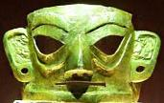

Fig. Junsha bronze mask silimar to those at Saningdui. From Jinsha Museum,

The **Shu** Kingdom (蜀; Shǔ) or [state](http://en.wikipedia.org/wiki/State_%28Ancient_China%29) in what is now [Sichuan](http://en.wikipedia.org/wiki/Sichuan), [China](http://en.wikipedia.org/wiki/China). Shu was based on the [Chengdu Plain](http://en.wikipedia.org/wiki/Chengdu_Plain), in the western [Sichuan basin](http://en.wikipedia.org/wiki/Sichuan_basin) with some extension northeast to the upper [Han River valley](http://en.wikipedia.org/wiki/Han_River_%28Hanshui%29). To the east was [the Ba tribal confederation](http://en.wikipedia.org/wiki/Ba_%28state%29). Further east down the Han and Yangtze rivers was the [State of Chu](http://en.wikipedia.org/wiki/Chu_%28state%29). To the north over the [Qinling Mountains](http://en.wikipedia.org/wiki/Qinling_Mountains) was the [State of Qin](http://en.wikipedia.org/wiki/Qin_%28state%29). To the west and south were tribal peoples of little military power.

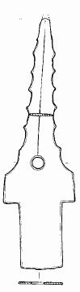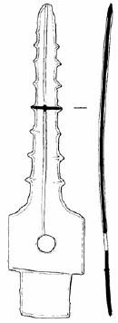

Fig. Left Sanxingdui serrated bronze *ge* blade, 20.5 cm., after Beijing 1999a: 56, fig. 32.5; right, Jinsha serrated bronze *ge* bladeafter Beijing2002c: 56.

*ge*-blades on the other hand, appear to have some resemblance to those of Fu Hao's tomb.

Knapp, R. G. 2000. China's old dwellings. Honolulu: University of Hawai'i Press.

Panin, V.; Arzhantseva, A.; Oleaga, G. 2012. The application of cliff degradation models for estimation of the initial height of rammed-earth walls (Por-Bajin fortress, southern Siberia, Russia. Archaeometry 2012. (Author's offprint).

Rael, R. 2009. Earth architecture. New York: Princeton University Press.

until 1986, when workers accidentally found sacrificial pits containing thousands of gold, bronze, jade, and pottery artifacts that had been broken (perhaps ritually disfigured), burned, and carefully buried. The first sacrificial pit was found on the site of the Lanxing Second Brick Factory on July 18th 1986. The second sacrificial pit was found a little less than a month later on August 14th, 1986 only 20-30 meters from the first one. Bronze objects found in the second sacrificial pit included male sculptures, animal-faced sculptures, bells, decorative animals such as dragons, snakes, chicks, and birds, and axes. Tables, masks and belts were some of the objects found made out of gold while objects made out of jade included axes, tablets, rings, knives and tubes. There was also a large amount of ivory and clamshells. Researchers were astonished to find an artistic style that was completely unknown in the history of [Chinese art](http://en.wikipedia.org/wiki/Chinese_art), whose baseline had been the history and artefacts of the Yellow River civilization(s).

All the Sanxingdui discoveries aroused scholarly interest, but the bronzes were what excited the world. Task Rosen of the [British Museum](http://en.wikipedia.org/wiki/British_Museum) considered them to be more outstanding than the [Terracotta Army](http://en.wikipedia.org/wiki/Terracotta_Army) in [Xi'an](http://en.wikipedia.org/wiki/Xi%27an). The first exhibits of Sanxingdui bronzes were held in [Beijing](http://en.wikipedia.org/wiki/Beijing) (1987, 1990) and the [Olympic Museum](http://en.wikipedia.org/wiki/Olympic_Museum) in Lausanne (1993). Sanxingdui exhibits traveled worldwide, and tickets were sold out everywhere; from the Hybary Arts Museum in [Munich](http://en.wikipedia.org/wiki/Munich) (1995), the [Swiss National Museum](http://en.wikipedia.org/wiki/Swiss_National_Museum) in Zurich (1996), the British Museum in London (1996), the [National Museum of Denmark](http://en.wikipedia.org/wiki/National_Museum_of_Denmark) in Copenhagen (1997), the [Solomon R. Guggenheim Museum](http://en.wikipedia.org/wiki/Solomon_R._Guggenheim_Museum) in New York (1998), several museums in [Japan](http://en.wikipedia.org/wiki/Japan) (1998), the [National Palace Museum](http://en.wikipedia.org/wiki/National_Palace_Museum) in Taipei (1999), to the [Asian Civilisations Museum](http://en.wikipedia.org/wiki/Asian_Civilisations_Museum) in Singapore (2007).

Nevertheless, despite the interest in the excavated finds, the site itself suffered from [flooding](http://en.wikipedia.org/wiki/Flood) and [pollution](http://en.wikipedia.org/wiki/Pollution), and was for this reason included in the [1996 World Monuments Watch](http://en.wikipedia.org/wiki/1996_World_Monuments_Watch) by the [World Monuments Fund](http://en.wikipedia.org/wiki/World_Monuments_Fund).[[6]](http://en.wikipedia.org/wiki/Sanxingdui#cite_note-6) For the preservation of the site, funding was offered by [American Express](http://en.wikipedia.org/wiki/American_Express) to construct a protective dike. Also, in 1997, the [Sanxingdui Museum](http://www.chinamuseums.com/sanxingduim.htm) opened near the original site.

Sanxingdui is a walled city belonging to the Sanxingdui Culture founded c 1,600 BCE. The trapizoidal city has an east wall 2,000 m, south wall 2,000 m, west wall 1,600 m enclosing 3.6 km2.[[2]](http://en.wikipedia.org/wiki/Sanxingdui#cite_note-2) The city was built on the banks of the [Yazi River](http://en.wikipedia.org/wiki/Jian_River) ([Chinese](http://en.wikipedia.org/wiki/Chinese_language): 涧河; [pinyin](http://en.wikipedia.org/wiki/Pinyin): Jiān Hé), and enclosed part of its tributary, Mamu River, within the city walls. The city is equal to the Shang capital [Ao](http://en.wikipedia.org/wiki/Guancheng_Hui_District) ([Chinese](http://en.wikipedia.org/wiki/Chinese_language): 隞; [pinyin](http://en.wikipedia.org/wiki/Pinyin): Aó) in scale and development. The city wall were 40 m at the base and 20 m at the top and varied in height from 8–10 m. There was a smaller set of inner walls. The walls were surrounded by canals 25–20 m wide and 2–3 m deep. These canals were used for irrigation, inland navigation, defense, and flood control. The city was divided into residential, industrial and religious districts organized around a dominant central axis. It is along this axis that most of the pit burial have been found on four terraces. The structures were timber framed adobe rectangular halls. The largest was a meeting hall about 200 m2.

The culture of the Sanxingdui site is thought to be divided into several phases. The Sanxingdui Culture which corresponds to periods **II**-**III** of the site, was a mysterious civilization in southern China.[[3]](http://en.wikipedia.org/wiki/Sanxingdui#cite_note-3) This culture is contemporaneous with the [Shang Dynasty](http://en.wikipedia.org/wiki/Shang_Dynasty), however they developed a different method of bronze-making from the Shang. The first phase which corresponds to period **I** of the site belongs to the [Baodun](http://en.wikipedia.org/wiki/Baodun_culture), and the final phase (period **IV**) the culture merged with [Ba](http://en.wikipedia.org/wiki/Ba_%28state%29) and [Chu](http://en.wikipedia.org/wiki/Chu_%28state%29) cultures. The Sanxingdui culture ended, possibly either as a result of natural disasters (evidence of massive flooding were found), or invasion by a different culture.[[4]](http://en.wikipedia.org/wiki/Sanxingdui#cite_note-4)

The culture was a strong central [theocracy](http://en.wikipedia.org/wiki/Theocracy) with trade links to bronze from [Yin](http://en.wikipedia.org/wiki/Yinxu) and Ivory from [Southeast Asia](http://en.wikipedia.org/wiki/Southeast_Asia). Such evidence of independent cultures in different regions of China defies the traditional theory that the [Yellow River](http://en.wikipedia.org/wiki/Yellow_River) was the sole "cradle of Chinese civilization."

is the name of an [archaeological site](http://en.wikipedia.org/wiki/Archaeological_site) and the previously unknown Bronze Age culture for which it is the type site. Sanxingdui is now believed to be the site of a major [ancient Chinese](http://en.wikipedia.org/wiki/History_of_China) city in what is now [Sichuan](http://en.wikipedia.org/wiki/Sichuan), [China](http://en.wikipedia.org/wiki/China). The [Bronze Age](http://en.wikipedia.org/wiki/Bronze_Age) culture which inhabited it was re-discovered in 1987 when [archaeologists](http://en.wikipedia.org/wiki/Archaeologist) excavated remarkable [artifacts](http://en.wikipedia.org/wiki/Artifact_%28archaeology%29), that [radiocarbon dating](http://en.wikipedia.org/wiki/Radiocarbon_dating) dated as being from the 12th-11th centuries BCE. The culture that produced these artifacts is now known as the *Sanxingdui Culture*, and archeologists are identifying it with the ancient kingdom of [Shu](http://en.wikipedia.org/wiki/Shu_%28state%29). The artifacts are displayed in the [Sanxingdui Museum](http://en.wikipedia.org/wiki/Sanxingdui_Museum) located near the city of [Guanghan](http://en.wikipedia.org/wiki/Guanghan).

The discovery at Sanxingdui, as well as other discoveries such as the [Xingan](http://en.wikipedia.org/wiki/Xingan_%28archaeological_site%29) tombs in Jiangxi, challenges the traditional narrative of Chinese civilization spreading from the central plain of the [Yellow River](http://en.wikipedia.org/wiki/Yellow_River), and Chinese archaeologists have began to speak of "multiple centers of innovation jointly ancestral to Chinese civilization."[[1]](http://en.wikipedia.org/wiki/Sanxingdui#cite_note-1)

For the absolute dating of the Sanxingdui site, the report of the

1980–81 excavations (including remarks about the 1982 excavations)

relied on the following evidence (Sichuan 1987a: 249). A calibrated

radiocarbon date was obtained from a sample of charcoal from Phase

I remains, which gives the uncalibrated radiocarbon date of 4075}100

BP (with 5730 half-life) and the calibrated date of 4500}100 BP.22 The

fine spiral pattern decorating some of the pottery vessels of Phase III are similar to the leiwen 雷紋 (rectilinear spirals) on Shang bronzes. Besides,

the upper stratum of the 1982 excavations yielded pottery vessels with

pointed bottom, the likes of which had appeared in abundance at the

Shuiguanyin 水觀音 site in Xindu 新都 County, a site that can be dated

to the end of the Shang period or the beginning of the Western Zhou

period through associations in bronze.23

3700–3370 calBCE (ZK-2591, Charcoal: wood)

3497–3040 calBCE (ZK-2330, Charcoal: wood)

2873–2502 calBCE (BK86046, Charcoal: wood)

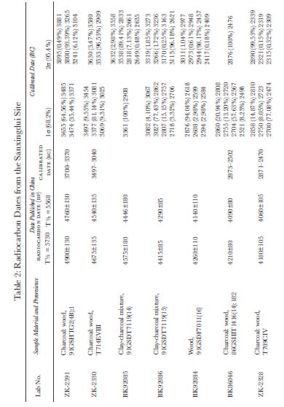

References cited

Asahi 1998: Asahi Shimbunsha 朝日新聞社 (editor) (1998). Sanseitai—

Chūgoku 5000 nen no nazo, kyōi no kamen ōkoku 三星堆—中国 5000 年

の謎・驚異の仮面王国 (Sanxingdui—China’s 5000-year old mystery,

kingdom of startling masks). Tōkyō: Asahi Shimbunsha.

Bagley, Robert (1987). Shang Ritual Bronzes in the Arthur M. Sackler Collections.

Washington, DC: Arthur M. Sackler Foundation.

Bagley, Robert (1988).“Sacrificial pits of the Shang period at Sanxingdui

in Guanghan County, Sichuan Province.” Arts Asiatiques 43 (1988):

78–86.

Bagley, Robert (1990). “A Shang city in Sichuan Province.” Orientations

(November 1990): 52–67. [Chinese translation published in Li Shaoming

et al. 1993: 69–75].

Bagley, Robert (1999). “Shang archaeology.” In Michael Loewe and

Edward L. Shaughnessy (eds.), The Cambridge History of Ancient China,

pp. 124–231. Cambridge: Cambridge University Press.

Bagley, Robert (editor) (2001). Ancient Sichuan: Treasures from a Lost Civilization.

Seattle: Seattle Art Museum in association with Princeton

University Press.

Barnard, Noel (1990). “Some preliminary thoughts on the significance

of the Kuang-han pit-burial bronzes and other artifacts.” Beitrage zur

allgemeinen und vergleichenden Archaologie 9–10 (1990): 249–279. [Chinese

translation published in Nanfang minzu kaogu 南方民族考古 5 (1992):

25–66.]

Beijing 1996: Beijing Daxue Kaoguxi Tanshisi Shiyanshi 北京大學考

古系碳十四實驗室 (1996). “Tanshisi niandai ceding baogao (yiling)

碳十四年代測定報告 (一○) (Report of radiocarbon dates, No. 10)”.

Wenwu 文物 1996.6: 91–95.

Bowman, Sheridan (1990). Radiocarbon Dating. London: British Museum

Publications.

Chen De’an 陳德安 (1998). “Sanxingdui yizhi de faxian yu yanjiu 三星

堆遺址的發現與研究 (Discovery and study of the Sanxingdui site).”

Zhonghua wenhua luntan 中華文化論壇 1998.2: 57–63. Chengdu.

Chen De’an, Wei Xuefeng 魏學峰, and Li Weigang 李偉綱 (1998). Sanxingdui:

Changjiang shangyou wenming zhongxin tansuo 三星堆: 長江上游

文明中心探索 (Sanxingdui: Exploring the center of civilization in

the upper reaches of the Changjiang River). Chengdu: Sichuan Renmin

Chubanshe.

Chen Xiandan 陳顯丹 (1988). “Lun Guanghan Sanxingdui yizhi de

xingzhi 論廣漢三星堆遺址的性質 (On the nature of the Sanxingdui

site of Guanghan).” Sichuan wenwu 四川文物 1988.4: 9–11, 8.

Chen Xiandan (1989). “Guanghan Sanxingdui yizhi fajue gaikuang,

DEFININg THE CULTURES AT SANXINDUI 183

chubu fenqi—jianlun ‘zao Shu wenhua’ de tezheng jiqi fazhan 廣漢

三星堆遺址發掘概況, 初步分期—兼論 ‘早蜀文化’ 的特徵及其發

展 (Brief account of excavations and preliminary periodization of the

Sanxingdui site in Guanghan—concurrently on the characteristics

of the ‘early Shu Culture’ and its development).” Nanfang minzu kaogu

2 (1989): 213–229.

Chen, Xiandan (1999). “The sacrificial pits at Sanxingdui: their nature

and date.” In Roderick Whitfield and Wang Tao (translators and eds.),

Exploring China’s Past: New Discoveries and Studies in Archaeology and Art,

pp. 165–171. London: Saﬀron Books.

Chen Xiandan (2001). “Guanghan Sanxingdui dashiji 廣漢三星堆大

事記 (1929–2000.2) (Chronicle of Guanghan Sanxingdui [1929–

2000.2]).” Zhonghua wenhua luntan 2001.1: 41–45.

Chen Xiandan and Liu Jiasheng 劉家勝 (2002). “Lun Sanxingdui

wenhua yu Baodun wenhua zhi guanxi 論三星堆文化與寶墩文化

之關係 (On the relationship between the Sanxingdui Culture and

the Baodun Culture).” Sichuan wenwu 2002.4: 3–6.

Cheng, Te-k’un [= Zheng Dekun] (1949). “The T’ai-p’ing-ch’ang Culture,

Szechwan.” Hsieh-ta Journal of Chinese Studies 1 (1949): 67–81.

Chengdu. Reprinted in Cheng, Te-k’un (1982), Studies in Chinese

Archaeology, pp. 55–65. Hong Kong: The Chinese University Press.

Chengdu 1997: Chengdu Shi Wenwu Kaogu Gongzuodui 成都市文物

考古工作隊 and Xindu Xian Wenwu Guanlisuo 新都縣文物管理

所 (1997). “Sichuan Xindu Xian Guilinxiang Shang dai yizhi fajue

jianbao 四川新都縣桂林鄉商代遺址發掘簡報 (Preliminary report

of excavation of a Shang period site at Guilinxiang in Xindu County,

Sichuan).” Wenwu 1997.3: 24–34.

Chengdu 1998: Chengdu Shi Wenwu Kaogu Gongzuodui, Sichuan

Lianhe

Daxue Lishixi Kaogu Jiaoyanshi 四川聯合大學歷史系考

古教研室, and Xinjin Xian Wenguansuo 新津縣文管所 (1998).“Sichuan

Sheng Wenjiang Xian Yufucun yizhi diaocha yu shijue 四川省

溫江縣魚鳧村遺址調查與試掘 (Survey and test excavation at the Yufucun

site in Wenjiang County, Sichuan.” Wenwu 1998.12: 38–56.

Chengdu 2001: Chengdu Shi Wenwu Kaogu Yanjiusuo 成都市文物

考古研究所, and Pixian Bowuguan 郫縣博物館 (2001). “Sichuan

Sheng Pixian Qingjiangcun yizhi diaocha fajue shouhuo 四川省郫

縣清江村遺址調查發掘收獲 (Results of survey and excavation of

the Qingjiangcun site at Pixian County, Sichuan). In Chengdu Shi

Wenwu Kaogu Yanjiusuo (editor), Chengdu kaogu faxian 1999 成都

考古發現 1999 (Archaeological discoveries in Chengdu 1999), pp.

146–163. Beijing: Kexue Chubanshe.

Chengdu 2002: Chengdu Shi Wenwu Kaogu Yanjiusuo and Beijing

Daxue Kaogu Wenboyuan 北京大學考古文博院 (2002). Jinsha

184 jay xu

taozhen—Chengdu Shi Jinshacun yizhi chutu wenwu 金沙淘珍—–成都

市金沙村遺址出土文物 (Panning for treasure at Jinsha—Artifacts

unearthed at Jinshacun, Chengdu). Beijing: Wenwu Chubanshe.

Chengdu 2003a: Chengdu Shi Wenwu Kaogu Yanjiusuo and Pixian

Bowuguan (2003). “Sichuan Pixian Qingjiangcun yizhi fajue jianbao

四川郫縣清江村遺址發掘簡報 (Preliminary report of excavation of

the Qingjiangcun site at Pixian County, Sichuan).” Wenwu 2003.1:

56–64.

Chengdu 2003b: Chengdu Shi Wenwu Kaogu Gongzuodui (2003).

“Chengdu Shi Hetaocun Shang dai yizhi fajue jianbao 成都市核桃

村商代遺址發掘簡報 (Preliminary report of excavation of a Shang

period site at Hetaocun in Chengdu).” Wenwu 2003.4: 21–25.

Falkenhausen, Lothar von (2002). “Some reflections on Sanxingdui.”

In I-tien Hsing (editor), Regional Culture, Religion, and Arts before the

Seventh Century: Papers from the Third International Conference on Sinology,

History Section, pp. 59–97. Taipei: Institute of History and Philology,

Academia Sinica.

Falkenhausen, Lothar von (2003). “La culture de Sanxingdui: sources

et contacts.” In Paris–Musees (editor), Chine, l’enigme de l’homme de

bronze: Archeologie du Sichuan (XII–III siecle av. j.-c.), pp. 47–59. Paris:

Paris–Musees.

Ge, Yan and Katheryn M. Linduﬀ (1990). “Sanxingdui: a new Bronze

Age site in Southwest China.” Antiquity 64 (1990): 505–513. [Chinese

translation published in Sichuan wenwu 1991.6: 71–77.]

Goepper, Roger (editor) (1995). Das alte China: Menschen und Gotter im

Reich der Mitte. Essen: Kulturstiftung Ruhr.

Graham, David C. (1934). “A preliminary report of the Hanchow excavation.”

Journal of the West China Border Research Society 6: 114–131.

Chengdu.

Henan 2001: Henan Sheng Wenwu Kaogu Yanjiusuo 河南省文物

考古研究所 (2001). Zhengzhou Shang cheng—1953–1985 nian kaogu

fajue baogao 鄭州商城—1953–1985 年考古發掘報告 (Report of the

1953–1985 excavations of the Shang city at Zhengzhou). Beijing:

Wenwu Chubanshe.

Huang Jiaxiang 黃家祥 (1990). “‘Guanghan Sanxingdui yizhi’ de chubu

fenxi ‘廣漢三星堆遺址’ 的初步分析 (Preliminary analysis of ‘the

Sanxingdui

site at Guanghan’).” Kaogu 考古 1990.11: 1030–1036.

Jiang Zhanghua 江章華 (1998a). “Shilun Sanxingdui wenhua Shi’erqiao

wenhua yu zhoulin wenhua de guanxi 試論三星堆文化十二橋文化

與周鄰文化的關係 (Preliminary discussion of the relationships between

the Sanxingdui Culture, the Shi’erqiao Culture, and cultures

of neighboring regions).” Chengdu wenwu 成都文物 1998.1: 4–11.

Jiang Zhanghua (1998b). “Chengdu Shi’erqiao yizhi de wenhua xingzhi

ji fenqi yanjiu 成都十二橋遺址的文化性質及分期研究 (A study of

DEFININg THE CULTURES AT SANXINDUI 185

cultural identity and periodization of the Shi’erqiao site of Chengdu).”

In Sichuan Daxue Kaogu Zhuanye 四川大學考古專業 (editor),

Sichuan Daxue Kaogu Zhuanye chuangjian sanshiwu zhounian jinian wenji 四

川大學考古專業創建三十五周年紀念文集 (Collection of papers

in commemoration of the thirty fifth anniversary of the founding of

the archaeology program in the Sichuan University), pp. 146–164.

Chengdu: Sichuan Daxue Chubanshe.

Jiang Zhanghua and Li Mingbin 李明斌 (2002). Guguo xunzong: Sanxingdui

wenhua de xingqi jiqi yingxiang 古國尋蹤: 三星堆文化的興起及其

影響 (In search of the ancient kingdom: the rise of the Sanxingdui

Culture and its influence). Chengdu: Ba Shu Shushe.

Jiang Zhanghua, Wang Yi 王毅, and Zhang Qing 張擎 (2002). “Chengdu

Pingyuan Xian Qin wenhua chulun 成都平原先秦文化初論

(Preliminary discussion of pre-Qin cultures in the Chengdu Plain).”

Kaogu xuebao 考古學報 2002.1: 1–22.

Li Boqian 李伯謙 (1997). “Dui Sanxingdui wenhua ruogan wenti

de renshi 對三星堆文化若干問題的認識 (Views regarding a few

questions on the Sanxingdui Culture).” Kaoguxue yanjiu 考古學研究

3 (1997): 84–94.

Li Mingbin 李明斌 (1999a). “Guanghan Yueliangwan yicun shixi 廣

漢月亮灣遺存試析 (Tentative analysis of the remains at Guanghan

Yueliangwan).” Huaxia kaogu 華夏考古 1999.1: 26–35, 59.

Li Mingbin (1999b). “Sichuan Ya’an Shaxi yizhi taoqi ji xiangguan

wenti de chubu yanjiu 四川雅安沙溪遺址陶器及相關問題的初步

研究 (Preliminary study of pottery and related problems of the Shaxi

site in Ya’an, Sichuan).” Kaogu 1999.2: 75–81.

Li Mingbin (2001a). “Shilun Yufucun yizhi disanqi yicun 試論魚鳧村

遺址第三期遺存 (Preliminary discussion of Phase 3 remains at the

Yufucun site).” Kaogu yu wenwu 考古與文物 2001.1: 40–41, 48.

Li Mingbin (2001b). “Guanyu Sanxingdui yizhi diyiqi wenhua yicun

de jige wenti 關於三星堆遺址第一期文化遺存的幾個問題 (Some

questions concerning Phase I cultural remains in the Sanxingdui

site).” Chengdu wenwu 2001.2: 56–61.

Li Mingbin (2003). “Yangzishan tutai zai kao 羊子山土台再考 (A further

study of the terraced mound at Yangzishan).” Gudai wenming 古

代文明 2 (2003): 241–251.

Li Shaoming 李紹明, Lin Xiang 林向, and Xu Nanzhou 徐南洲 (eds.)

(1991). Ba Shu lishi, minzu, kaogu, wenhua 巴蜀歷史, 民族, 考古, 文化

(History, ethnic identity, archaeology, and culture of Ba and Shu).

Chengdu: Ba Shu Shushe.

Li Shaoming, Lin Xiang, and Zhao Dianzeng 趙殿增 (eds.) (1993).

Sanxingdui yu Ba Shu wenhua 三星堆與巴蜀文化 (Sanxingdui and the

Ba–Shu Culture). Chengdu: Ba Shu Shushe.

Lin Xiang 林向 (1988). “Yangzishan jianzhu yizhi xin kao 羊子山建築

186 jay xu

遺址新考 (A new study of the architectural remains at Yangzishan).”

Sichuan wenwu 1988.5: 3–8.

Liu, Yang and Edmund Capon (2000). Masks of Mystery: Ancient Chinese

Bronzes from Sanxingdui. Sydney: Art Gallery of New South Wales.

Louis, Francois (2003). “L’or au Sichuan a l’age du bronze.” In Paris–

Musees (editor), Chine, l’enigme de l’homme de bronze: Archeologie du Sichuan

(XII–III siecle av. j.-c.), pp. 157–165. Paris: Paris–Musees.

Luan Fengshi 欒豐實, Fang Hui 方輝, and Jin Guiyun 靳桂雲 (2002).

Kaoguxue lilun fangfa jishu 考古學理論方法技術 (Theories, methods,

and techniques of Archaeology). Beijing: Wenwu Chubanshe.

Ma Jixian 馬繼賢 (1992). “Guanghan Yueliangwan yizhi fajue zhuiji 廣

漢月亮灣遺址發掘追記 (Recollections of the excavations at Guanghan

Yueliangwan).” Nanfang minzu kaogu 5: 310–323.

Ma Xinxin 馬辛辛 (1993). “Daba shanmai yu chuanbei shiqian wenhua

de tantao 大巴山脈與川北史前文化的探討 (Discussion concerning

prehistoric cultures in the Daba Mountains and northern Sichuan).”

Sichuan wenwu 1993.5: 8–14.

Nishie Kiyotaka 西江清高 (editor) (2002). Fusang yu Ruomu—Riben xuezhe

dui Sanxingdui wenming de xin renshi 扶桑與若木—–日本學者對三星

堆文明的新認識 (New understandings by Japanese scholars on the

Sanxingdui civilization). Chengdu: Ba Shu Shushe.

Paris 2003: Paris–Musees (editor) (2003). Chine, l’enigme de l’homme de bronze:

Archeologie du Sichuan (XII–III siecle av. j.-c.). Paris: Paris–Musees.

Rawson, Jessica (editor) (1996). Mysteries of Ancient China. London: British

Museum.

Sichuan 1957: Sichuan Sheng Wenwu Guanli Weiyuanhui 四川省文物

管理委員會 (1957). “Chengdu Yangzishan tutai yizhi qingli baogao

成都羊子山土台遺址清理報告 (Salvage report of remains of the

Yangzishan terrace in Chengdu).” Kaogu xuebao 1957.4: 17–31.

Sichuan 1959: Sichuan Sheng Bowuguan 四川省博物館 (1959). “Sichuan

Xinfan Shuiguanyin yizhi fajue jianbao 四川新繁水觀音遺

址發掘簡報 (Preliminary report of excavation of the Shuiguanyin

site at Xinfan, Sichuan).” Kaogu 1959.8: 404–410.

Sichuan 1961: Sichuan Daxue Lishixi Kaoguxue Jiaoyanzu 四川大學

歷史系考古學教研組 (1961). “Guanghan Zhongxing gongshe gu

yizhi diaocha jianbao 廣漢中興公社古遺址調查簡報 (Preliminary

report of field survey of the ancient site at the Zhongxing Commune

of Guanghan).” Wenwu 1961.11: 22–27.

Sichuan 1987a: Sichuan Sheng Wenwu Guanli Weiyuanhui, Sichuan

Sheng Bowuguan, and Guanghan Xian Wenhuaguan 廣漢縣文化

館 (1987). “Guanghan Sanxingdui yizhi 廣漢三星堆遺址 (The Sanxingdui

site at Guanghan).” Kaogu xuebao 1987.2: 227–254.

Sichuan 1987b: Sichuan Sheng Wenwu Guanli Weiyuanhui, Sichuan

Sheng Wenwu Kaogu Yanjiusuo 四川省文物考古研究所, and

DEFININg THE CULTURES AT SANXINDUI 187

Sichuan

Sheng Guanghan Xian Wenhuaju 四川省廣漢縣文化局

(1987). “Guanghan Sanxingdui yizhi yihao jisikeng fajue jianbao 廣漢

三星堆遺址一號祭祀坑發掘簡報 (Preliminary report of excavation

of No. 1 sacrificial pit at Sanxingdui).” Wenwu 1987.10: 1–15.

Sichuan 1987c: Sichuan Sheng Wenwu Guanli Weiyuanhui, Sichuan

Sheng Wenwu Kaogu Yanjiusuo, and Chengdu Shi Bowuguan 成都

市博物館 (1987). “Chengdu Shi’erqiao Shang dai jianzhu yizhi diyiqi

fajue jianbao 成都十二橋商代建築遺址第一期發掘簡報 (Preliminary

report of the first excavation of the Shang period architectural

remains at Chengdu Shi’erqiao).” Wenwu 1987.12: 1–23, 37.

Sichuan 1989: Sichuan Sheng Wenwu Guanli Weiyuanhui, Sichuan

Sheng Wenwu Kaogu Yanjiusuo, and Guanghan Shi Wenhuaju

Wenguansuo

廣漢市文化局文管所 (1989). “Guanghan Sanxingdui

yizhi erhao jisikeng fajue jianbao 廣漢三星堆遺址二號祭祀坑發

掘簡報 (Preliminary report of excavation of Sacrificial Pit No. 2 at

Sanxingdui).”

Wenwu 1989.5: 1–20.

Sichuan 1990: Sichuan Sheng Wenwu Guanli Weiyuanhui, Sichuan

Sheng Wenwu Kaogu Yanjiusuo, and Sichuan Sheng Ya’an Diqu

Wenwu Guanlisuo 四川省雅安地區文物管理所 (1990). “Ya’an

Shaxi yizhi fajue ji diaocha baogao 雅安沙溪遺址發掘及調查報告

(Report of excavation and survey of the Shaxi site at Ya’an).” Nanfang

minzu kaogu 3: 293–339.

Sichuan 1992: Sichuan Sheng Wenwu Kaogu Yanjiusuo Sanxingdui

Gongzuozhan

四川省文物考古研究所三星堆工作站, Sichuan

Sheng Guanghan Shi Wenguanhui 四川省廣漢市文管會, and Shifang

XianWenguansuo 什邡縣文管所 (1992). “Sichuan Guanghan,

Shifang Shang Zhou yizhi diaocha baogao 四川廣漢, 什邡商周遺址

調查報告 (Report of field surveys of Shang and Zhou sites in Guanghan

and Shifang of Sichuan).” Nanfang minzu kaogu 5: 295–309.

Sichuan 1998: Sichuan Sheng Wenwu Kaogu Yanjiusuo Sanxingdui

Gongzuozhan,

and Guanghan Shi Wenwu Guanlisuo 廣漢市文物

管理所 (1998). “Sanxingdui yizhi Zhenwu Cangbaobao jisikeng diaocha

jianbao 三星堆遺址真武倉包包祭祀坑調查簡報 (Preliminary

report of investigation of a sacrificial pit at Zhenwu Cangbaobao in

the Sanxingdui site).” In Sichuan Sheng Wenwu Kaogu Yanjiusuo

(editor), Sichuan kaogu baogaoji 四川考古報告集 (Collection of excavation

reports of Sichuan), pp. 78–90. Beijing: Wenwu Chubanshe.

Sichuan 1999: Sichuan Sheng Wenwu Kaogu Yanjiusuo (editor) (1999).

Sanxingdui jisikeng 三星堆祭祀坑 (Excavation of the sacrificial pits at

Sanxingdui). Beijing: Wenwu Chubanshe.

So, Jenny F. (2001). “Jade and stone at Sanxingdui.” In Robert Bagley

(editor), Ancient Sichuan: Treasures from a Lost Civilization, pp. 153–175.

Seattle: Seattle Art Museum in association with Princeton University

Press.

188 jay xu

Song Zhimin 宋治民 (1983). “Guanyu Shu wenhua de jige wenti 關於

蜀文化的幾個問題 (A few questions concerning the Shu Culture).”

Kaogu yu wenwu 1983.2: 71–80.

Song Zhimin (1991). “Cong Sanxingdui de xin faxian kan zaoqi Shu

wenhua 從三星堆的新發現看早期蜀文化 (The early Shu Culture

in the light of new discoveries at Sanxingdui).” In Li Shaoming et al.

(eds.), Ba Shu lishi, minzu, kaogu, wenhua 巴蜀歷史·民族·考古·文

化 (History, ethnic identity, archaeology, and culture of Ba and Shu),

pp. 207–223. Chengdu: Ba Shu Shushe.

Stuiver, Minze, Reimer, Paula J., and Reimer, R. W. (2005). CALIB

5.0. [WWW program and documentation]. <http://radiocarbon.

pa.qub.ac.uk/calib/>.

Sun Hua (1992). “Shilun Guanghan Sanxingdui yizhi de fenqi 試論

廣漢三星堆遺址的分期 (Preliminary discussion of periodization of

the Sanxingdui site of Guanghan).” Nanfang minzu kaogu 5: 10–24.

Reprinted in Sun Hua 2000: 49–67.

Sun Hua (1993). “Yangzishan tutai kao 羊子山土台考 (Study of the

terraced mound at Yangzhishan).” Sichuan wenwu 1993.1: 3–7.

Sun Hua (1996). “Chengdu Shi’erqiao yizhiqun fenqi chulun 成都十

二橋遺址群分期初論 (Preliminary discussion of periodization of the

cluster of Shi’erqiao sites in Chengdu).” In Sichuan Sheng Wenwu

Kaogu Yanjiusuo (editor), Sichuan kaogu lunwenji 四川考古論文集

(Collection of research papers on Sichuan archaeology), pp. 123–144.

Beijing: Wenwu Chubanshe. Reprinted in Sun Hua 2000: 68–88.

Sun Hua (2000). Sichuan pendi de qingtong shidai 四川盆地的青銅時代

(Bronze Age of the Sichuan Basin). Beijing: Kexue Chubanshe.

Taipingyang 1999: Taipingyang Wenhua Jijinhui 太平洋文化基金會

(1999). Sanxingdui chuanqi, Huaxia gu wenming de tansuo 三星堆傳奇,

華夏古文明的探索 (Legend of Sanxingdui: exploring the ancient

civilization of Huaxia). Taipei: Taipingyang Wenhua Jijinhui.

Thote, Alain (2003). “Le jade et la pierre a Sanxingdui.” In Paris–Musees

(editor), Chine, l’enigme de l’homme de bronze: Archeologie du Sichuan (XII–III

siecle av. j.-c.), pp. 113–132. Paris: Paris–Musees.

Wang Jiayou 王家祐 and Jiang Dianchao 江甸潮 (1958). “Sichuan

Xinfan Guanghan gu yizhi diaocha ji 四川新繁廣漢古遺址調查記

(Notes of field surveys in Xinfan and Guanghan of Sichuan).” Kaogu

tongxun 考古通訊 1958.8: 27–31.

Wang Renxiang 王仁湘 and Ye Maolin 葉茂林 (1993). “Sichuan pendi

beiyuan xinshiqi shidai kaogu xinshouhuo 四川盆地北緣新石器時

代考古新收獲 (New results in archaeology of the Neolithic period

in the northern edges of the Sichuan Basin).” In Li Shaoming et

al. (eds.), Sanxingdui yu Ba Shu wenhua (Sanxingdui and the Ba–Shu

Culture), pp. 257–265. Chengdu: Ba Shu Shushe.

Wang Yi 王毅 (1991). “Chengdu Shi Ba Shu wenhua yizhi de xin

DEFININg THE CULTURES AT SANXINDUI 189

faxian 成都市巴蜀文化遺址的新發現 (New discoveries of Ba–Shu

culture sites in Chengdu).” In Li Shaoming et al. (eds.), Sanxingdui yu

Ba Shu wenhua (Sanxingdui and the Ba–Shu Culture), pp. 295–309.

Chengdu: Ba Shu Shushe.

Wang Yi, Jiang Cheng 蔣成, and Jiang Zhanghua (1999). “Chengdu

diqu jinnian kaogu zongshu 成都地區近年考古綜述 (A general survey

of archaeology in the Chengdu region in recent years).” Sichuan

wenwu 1999.3: 3–12.

Wang Yi and Sun Hua (1999). “Baoduncun wenhua de chubu renshi 寶

墩村文化的初步認識 (Preliminary understanding of the Baoduncun

Culture).” Kaogu 1999.8: 60–73.

Wang Yi and Zhang Qing 張擎 (1999). “Sanxingdui wenhua yanjiu 三

星堆文化研究 (A study of the Sanxingdui Culture).” Sichuan wenwu

1999.3: 13–22.

Xi’nan 1954: Xi’nan Bowuyuan Choubeichu 西南博物院籌備處 (1954).

“Baocheng tielu xiuzhu gongcheng zhong faxian de wenwu jianjie 寶

成鐵路修築工程中發現的文物簡介 (Brief introduction of cultural

remains discovered during the construction of the Baoji–Chengdu

railroad).” Wenwu cankao ziliao 文物參考資料1954.3: 10–34.

Xiao Xianjin 蕭先進, Ao Tianzhao 敖天照, Liu Jiasheng 劉家勝, and

Bao Yuzhi 包育智 (2001). Sanxingdui faxian fajue shimo 三星堆發現發

掘始末 (The story of the discovery and fieldwork at Sanxingdui).

Chengdu: Sichuan Renmin Chubanshe.

Xu, Jay (2001a). “Sichuan before the Warring States Period.” In Robert

Bagley (editor), Ancient Sichuan: Treasures from a Lost Civilization, pp.

21–37. Seattle: Seattle Art Museum in association with Princeton

University Press.

Xu, Jay (2001b). “Bronze at Sanxingdui.” In Robert Bagley (editor),

Ancient Sichuan: Treasures from a Lost Civilization, pp. 59–151. Seattle:

Seattle Art Museum in association with Princeton University Press.

Xu, Jay (2001c). “Reconstructing Sanxingdui imagery: some speculations.”

Orientations (May 2001): 32–44.

Xu, Jay (2003). “Le site de Sanxingdui.” “Metallurgie du bronze a Sanxingdui,”

“Les arbres en bronze de Sanxingdui.” In Paris–Musees

(editor), Chine, l’enigme de l’homme de bronze: Archeologie du Sichuan (XII–III

siecle av. j.-c.), pp. 35–46, 61–112, 135–155. Paris: Paris–Musees.

Zhao Dianzeng 趙殿增 (1987). “Ba Shu wenhua jige wenti de tantao

巴蜀文化幾個問題的探討 (Inquiries into a few problems of the Ba

Shu culture).” Wenwu 1987.10: 18–21.

Zhao, Dianzeng (1996). “The sacrificial pits at Sanxingdui.” In Jessica

Rawson (editor), Mysteries of Ancient China, pp. 232–239. London:

British Museum.

Zhao Dianzeng and Chen De’an 陳德安 (2001). “Yige chongman

huoli de xueke shengzhangdian—Su Bingqi xiansheng zhidao xia

190 jay xu

de Sanxingdui kaogu 一個充滿活力的學科生長點—–蘇秉琦先生

指導下的三星堆考古 (A research area full of vitality—Sanxingdui

archaeology under the guidance of Mr. Su Bingqi).” In Su Bai 宿白

(editor), Su Bingqi yu dangdai Zhongguo kaoguxue 蘇秉琦與當代中國考

古學 (Su Bingqi and Chinese archaeology at present), pp. 451–469.

Beijing: Kexue Chubanshe.

Zheng Dekun 鄭德坤 (= Cheng Te-k’un) (1946). Sichuan gudai wenhua

shi 四川古代文化史 (Cultural history of ancient Sichuan). Chengdu:

West China Union University Museum Monograph Series No. 1.

Zhongguo 1982: Zhongguo Shehui Kexueyuan Kaogu Yanjiusuo 中國

社會科學院考古研究所 (editor) (1982). Kaogu gongzuo shouce 考古工作

手冊 (Manual of field archaeology). Beijing: Wenwu Chubanshe.

Zhongguo 1990: Zhongguo Shehui Kexueyuan Kaogu Yanjiusuo

Sichuan

Gongzuodui 中國社會科學院考古研究所四川工作隊

(1990). “Sichuan Mianyang Bianduishan xinshiqi shidai yizhi diaocha

baogao 四川綿陽邊堆山新石器時代遺址調查報告 (Report of

field survey of the Neolithic period Bianduishan site at Mianyang,

Sichuan).” Kaogu 1990.4: 307–313.

Zhongguo 1991a: Zhongguo Shehui Kexueyuan Kaogu Yanjiusuo

Shiyanshi 中國社會科學院考古研究所實驗室 (1991). “Fangshexing

tansu ceding niandai baogao (shiba) 放射性碳素測定年代

報告 (十八) (Report of radiocarbon dates, No. 18).” Kaogu 1991.7:

657–663.

Zhongguo 1991b: Zhongguo Shehui Kexueyuan Kaogu Yanjiusuo (editor)

(1991). Zhongguo kaoguxue zhong tanshisi niandai shujuji, 1965–1991

中國考古學中碳十四年代數據集, 1965–1991 (Radiocarbon dates

in Chinese archaeology: 1965–1991). Beijing: Wenwu Chubanshe.

Zhongguo 1992: Zhongguo Shehui Kexueyuan Kaogu Yanjiusuo Shiyanshi

(1992). “Fangshexing tansu ceding niandai baogao (shijiu) 放

射性碳素測定年代報告 (十九) (Report of radiocarbon dates, No.

19).” Kaogu 1992.7: 655–662.

Zhongguo 1993: Zhongguo Shehui Kexueyuan Kaogu Yanjiusuo Shiyanshi

(1993). “Fangshexing tansu ceding niandai baogao (erling) 放

射性碳素測定年代報告 (二○) (Report of radiocarbon dates, No.

20).” Kaogu 1993.7: 645–649__